# September 2022

# Model Building_Exp1

<http://www.virtualsilcton.com/experimenter/studies/753798868>

Virtual Silcton Project Name: VR_Treadmill_Compass

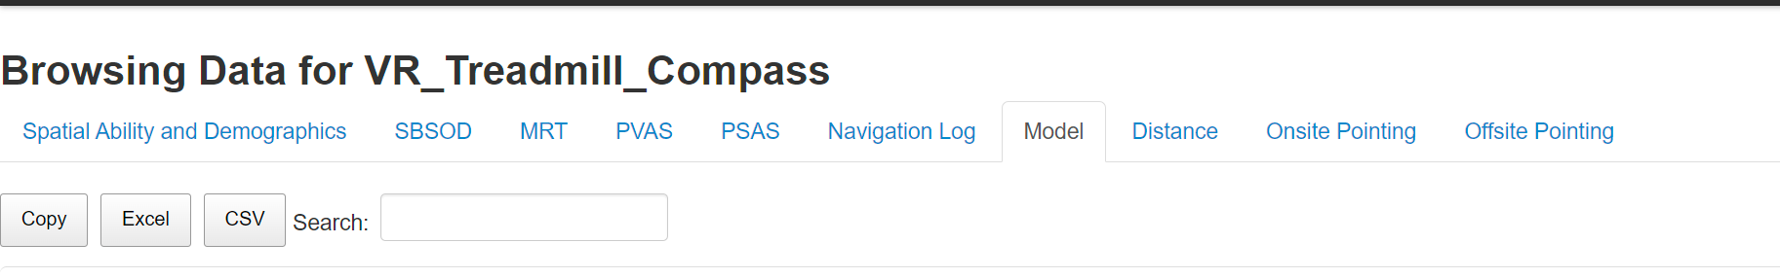

1. Download model data as csv
2. Download / copy “silctonBidi.R”
3. Download “mapTemplate.csv”
4. Run “line 4’: install.packages("BiDimRegression") in R .
5. Install the “here” package” on line 98.
6. Change the path to data by using the here package on line 101, changing the csv name.
7. Change the path to the template with the map template.
8. Run line 91 to save the output as csv.

Repeat the same steps for exp2.

# Pointing Task

Run Anaconda, then Spyder

To select and copy output logs:

1. Download copyPointingData_Exp1.py to copy output files from VS.
2. Run lines on their own.
3. Run the file.
4. Rerun line 25.

To get the pointing results (standalone)

1. Download “code_pointing_workingEce.py”
2. Install packages in Spyder (pandas)
3. Run Powershell
4. Set working directory by Set-Location -Path "C:\G-Drive"
5. Put input and output directory
6. Run the code!!!

G:\.shortcut-targets-by-id\1iQQpKU1ZuIM9lonWw4rXjIcMOMTundDC\SCANN Lab\EceYuksel\VR_CompassMountain\Raw_Data\processedData_Exp1\pointingData\rawPointing

python code_pointing_workingEce.py -i 'G:\.shortcut-targets-by-id\1iQQpKU1ZuIM9lonWw4rXjIcMOMTundDC\SCANN Lab\EceYuksel\VR_CompassMountain\Raw_Data\processedData_Exp1\pointingData\rawPointing' -o 'G:\.shortcut-targets-by-id\1iQQpKU1ZuIM9lonWw4rXjIcMOMTundDC\SCANN Lab\EceYuksel\VR_CompassMountain\Raw_Data\processedData_Exp1\pointingData'

python code_pointing_workingEce.py -i 'G:\.shortcut-targets-by-id\1iQQpKU1ZuIM9lonWw4rXjIcMOMTundDC\SCANN Lab\EceYuksel\VR_CompassMountain\Raw_Data\processedData_Exp2\pointingData\rawPointing' -o 'G:\.shortcut-targets-by-id\1iQQpKU1ZuIM9lonWw4rXjIcMOMTundDC\SCANN Lab\EceYuksel\VR_CompassMountain\Raw_Data\processedData_Exp2\pointingData'

To merge all pointing data to a long-form excel.

1. Run “mergePointingData_Exp2” in Spyder

## Long form to wide form

1. Run “longform_to_wideform_Exp1.R”

# Merging Data Sets

1. Run merging_data_updated_Exp1
2. Load in data, remember to change the excel sheet to csv, minding the variable names at the top.